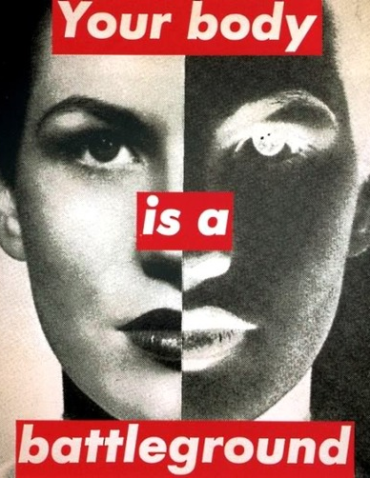
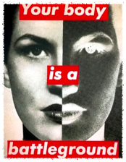
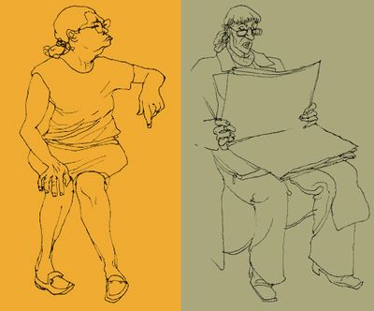
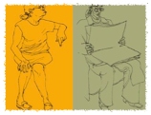



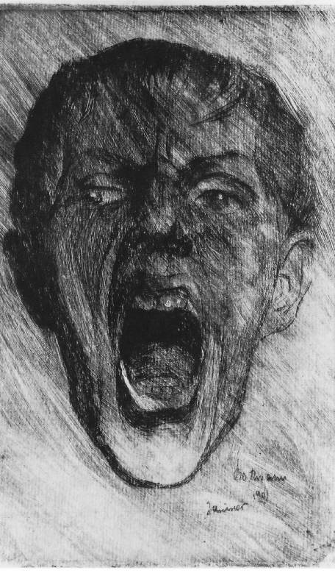
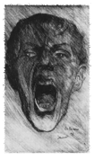

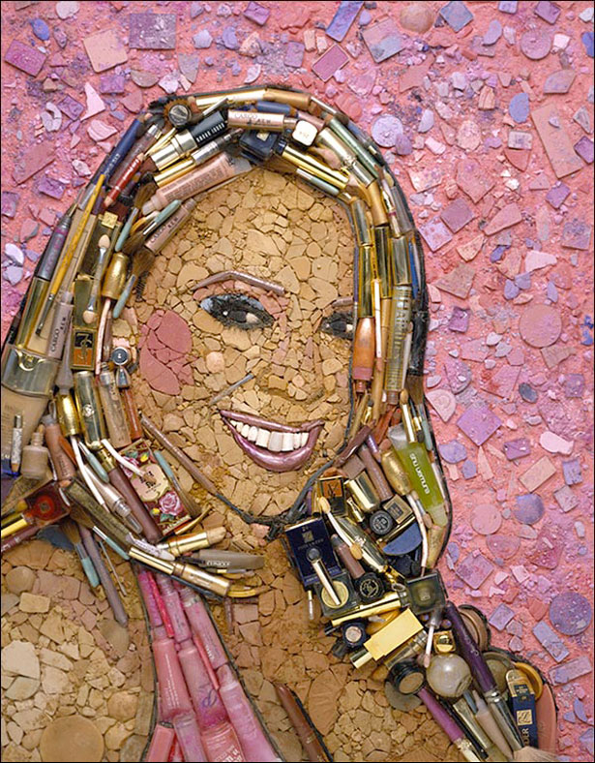
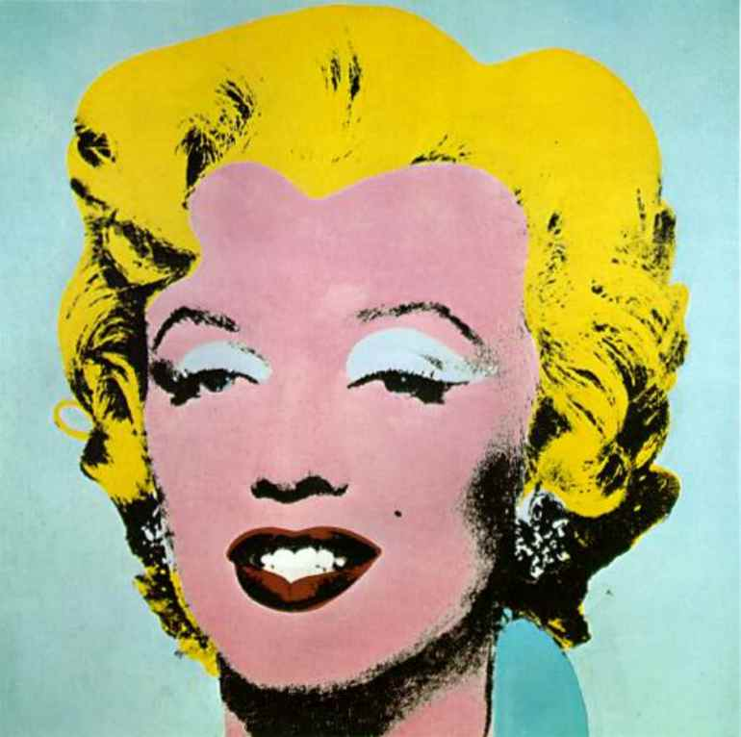
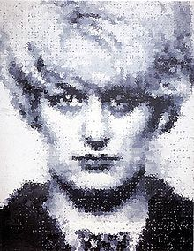
Identity
Learning Objectives:

AO1

Develop ideas through investigations informed by contextual and other sources demonstrating analytical and cultural understanding.

AO2

Refine ideas through experimenting and selecting appropriate resources, media, materials, techniques and processes.

AO3

Record ideas, observations and insights relevant to their intentions in visual and/or other forms.

AO4

Present a personal, informed and meaningful response demonstrating analytical and critical understanding, realising intentions and where appropriate, making connections between visual, written, oral or other elements.
Project Aim
Many artists use the theme of identity to explore their ideas. They use many different styles and techniques to represent people and their personalities.
You are to create a series of portraits each responding to a different artist and submitted as one piece of work in a sketchbook. You will be expected to research each artist and make comments on how they have influenced your ideas. The final outcome should be a collaborative piece reflecting the whole groups portraits.
TASK 1
RESEARCH
Find information and look at a selection of the artists work. Write about the artist describing their style of work and the techniques they used to create it. Use the information and links on both the Art wiki and our website essaart.weebly.com to help you. How has each artist captured the identity of the person in the portrait?

TASK 2
RESPOND
Create your own portrait inspired by the artist. Look carefully at the style and technique used by the artist and think how you could adapt this creatively in your own portrait. Consider the formal elements in each response and use media effectively to emulate the artists style.
TASK 3
EVALUATE
Describe your response and anlayse how successful you have been at capturing the identity of the person in the portrait. Present your work creatively in a concertina sketchbook then collaboratively with other members of the group to create an original outcome.

GCSE

