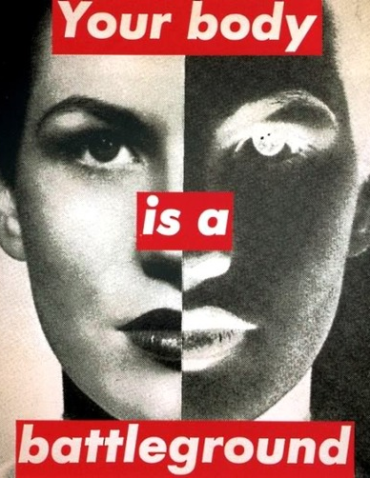
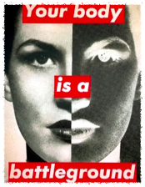
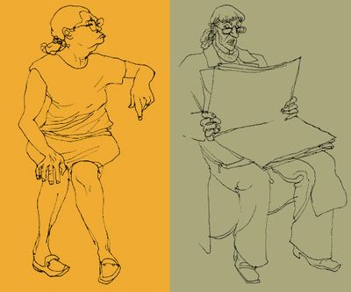
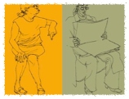



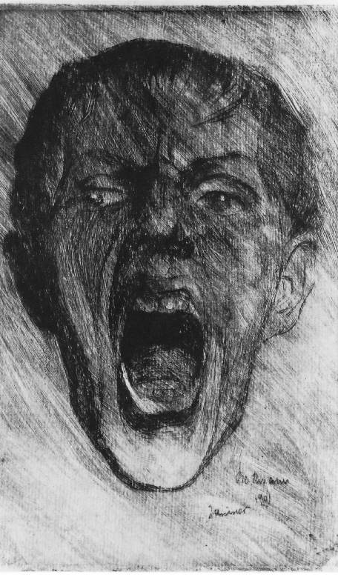
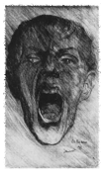


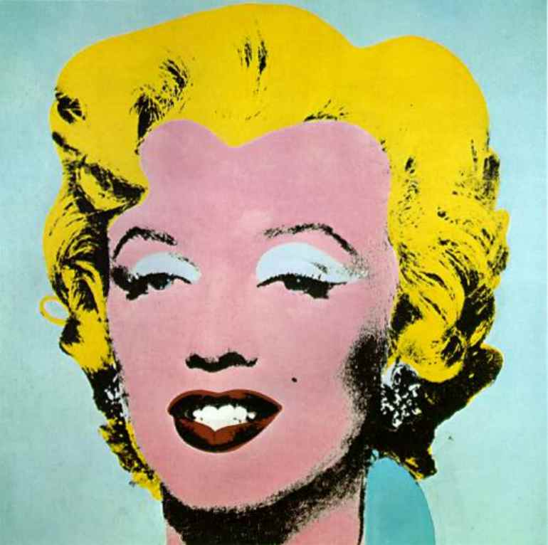
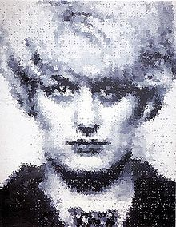
Identity
Learning Objectives:

Unit 1 - Contextual References in Art and Design

Know the influences of historical and contemporary art and design developments
Be able to use historical and contemporary references to support research and development of own response
Be able to present information about the work studied in an appropriate format.

Unit 2 - 2D Visual Communication

Be able to use 2D mark-making techniques
Be able to communicate design ideas using 2D visual communication techniques
Be able to use formal elements in 2D visual communication.

Scenario
The town hall has asked for artists to submit work for their next exhibition based on identity. The gallery wants to represent the changing face of the community and would like it to reflect a number of artists styles.
You are to create a series of portraits each responding to a different artist and submitted as one piece of work in a sketchbook. You will be expected to research each artist and make comments on how they have influenced your ideas. The final outcome should be a collaborative piece reflecting the whole groups portraits.
TASK 1
RESEARCH
Find information and look at a selection of the artists work. Write about the artist describing their style of work and the techniques they used to create it. Use the information and links on both the Art wiki and our website essaart.weebly.com to help you. How has each artist captured the identity of the person in the portrait?

TASK 2
RESPOND
Create your own portrait inspired by the artist. Look carefully at the style and technique used by the artist and think how you could adapt this creatively in your own portrait. Consider the formal elements in each response and use media effectively to emulate the artists style.
TASK 3
EVALUATE
Describe your response and anlayse how successful you have been at capturing the identity of the person in the portrait. Present your work creatively in a concertina sketchbook then collaboratively with other members of the group to create an original outcome.

BTEC CERTIFICATE
UNITS 1 & 2
Learner Name:Assessor: J McAnnVerifier: A ShinnDate Issued: 09/01/12Completion Date: 29/02/12Submitted on:

